Best Academy
After-School Enrichment Program
Parent Handbook
2019-2020

Table of Contents
Best Academy Programs………………………………………………..…..….3

Curriculum……………………………………………………………………......4

Enrollment and Fees……………………………………………………..…......5

Billing and Payment…………………………………………………….…..…...6

Cancellation Policies…………………………………………….……….…...…6

General Information, Policies, and Licensing Standards…………….….......7

Emergency School Closings, Delayed Openings, and Early Closings...…..8

Best Academy Programs

After-School Enrichment Program.

Hours of Operation: Best Academy’s After-School Enrichment operates from the end of the school day until 7 p.m. We will pick your child up from their school and drop them off at our center where they will sign in and have a snack.

Snack: A healthy snack is offered by Best Academy in the afternoon.

Teacher Workdays: Best Academy provides full day service from 7 a.m. to 7 p.m. on most FCPS teacher workdays. Children enrolled in the After-School Enrichment program may sign up to attend free of charge if they are enrolled for the week or semester. For students who are enrolled in daily or part-time registration, there is a $65 fee for the full day program. Please communicate with Best Academy’s staff to let them know whether or not your child will attend. On teacher workdays, please send a packed lunch and drink with the child’s name and date. Snack will be provided by Best Academy in the morning and afternoon.

Early Release: Best Academy provides additional care on scheduled FCPS early release days, free of charge. We will pick up your student from school and have special activities planned for the students.

Holidays: Please call the center or speak to our staff in advance about national holidays.

Winter and Spring Programs

Best Academy provides full day programs held during FCPS winter, spring, and summer breaks. Center hours vary by seasonal program. Enrollment and fees are separate for each program.

Summer Camp Program

Best Academy offers a variety of programs during the summer including 1st-8th grade enrichment, GT, TJ, SAT, and ESOL programs. Summer programs are 8 weeks long and typically start at 9 a.m. and end at 3 p.m., Monday to Friday.

Lunch: Best Academy provides the option to buy lunch from a local restaurant. If your child will not be buying lunch, please send a packed lunch and drink that does not require refrigeration or heating and label both with the child’s name and date.

Curriculum

Academics: Best Academy strives to provide academic support and enrichment for children to succeed in school. Every day, there will be a designated space and time for children to complete their homework and children will receive academic support needed to understand and complete their homework. Our teachers will encourage all students to complete their homework before moving onto learning labs and special activities. Students will have a separate reading time (DEAR) for 10 minutes every day after special activities.

Extracurriculars: Our learning labs and special activities include a rotation of reading & writing, mathematics, STEAM, and other special activities. Learning labs and special activities are done as a large group. After special activity, children will have 10 minutes of reading (D.E.A.R.- Drop Everything And Read) and then choice time, where they will be able to choose an activity such as Legos, board games, or tablet.

Field Trips: Throughout the year children may go on occasional field trips including hiking, bowling, and swimming.

Teachers: After-School Enrichment teachers have both academic backgrounds in child-related fields and experience working with children in small and large group settings. Many have graduate or post-graduate degrees in education, psychology, or other related fields. After-School Enrichment teachers ensure the safety of children, encourage acceptance of differences, provide experiential learning opportunities, and nurture independent thinking and creative expression.

Enrollment and Fees

You may enroll your child online through our website, over the phone, or in-person. Enrollment and fees are separate for each program and service. Enrollment is limited and openings are offered on a first come, first served basis. Best Academy allows weekly, semesterly, and yearly enrollment.

Program Fee: Best Academy allows weekly, semesterly, and yearly enrollment. Program fees are not adjusted based on attendance, absences, or early pick-up. Teacher work days and staff development days are included in the weekly, semesterly, and yearly enrollment. There is a separate fee for Full-Day Enrichment for daily or part-time enrollment (FCPS Teacher Work Days, some federal holidays, etc.).
Registration Fee: Families pay a one-time registration fee of $45 every year.

Late Pick-Up Fees: Our After-School Enrichment program ends at 7 p.m. If you are running late, please notify Best Academy before 7 p.m. If you have not contacted the center and staff cannot reach you, an emergency contact person listed on your child’s information form will be contacted to pick up your child. If staff cannot reach anyone within a reasonable period of time, it may be necessary to contact Child Protective Services. This will only be done with authorization from Best Academy staff.

We will bill a fee for every 15 minutes (or portion of 15 minutes) that a child is picked up late. Best Academy reserves the right to cancel service due to habitual or excessive lateness. For the first three occurrences, a late fee of $5 is charged for each 15 minutes. Late fees increase after three times. After three times, a late fee of $15 is charged for each 15 minutes. Late pick-up persons will be asked to sign a late pick-up form.

Billing and Payment

School Year Program: A partial payment of your child’s enrollment will need to be paid before your child attends their first session. Payment can be made online, over the phone, and in-person at our center by credit card, cash, or check. Please make checks payable to Best Academy.

Adjustments and Refunds: Fees will not be adjusted or refunded for absences, early pick-ups, cancelled field trips, unanticipated calendar changes or closings due to weather conditions, energy problems, or other emergency situations. Partial refunds will be given for cancellation of semesterly and yearly enrollment (see below).

Returned Checks: There will be a $50 charge for any check returned for insufficient funds.

Change of Address or Contact Information: Please notify Best Academy with any address, phone number or other contact information changes.

Billing Questions: If you have a question regarding payment, please contact Best Academy at 703-978-0008.
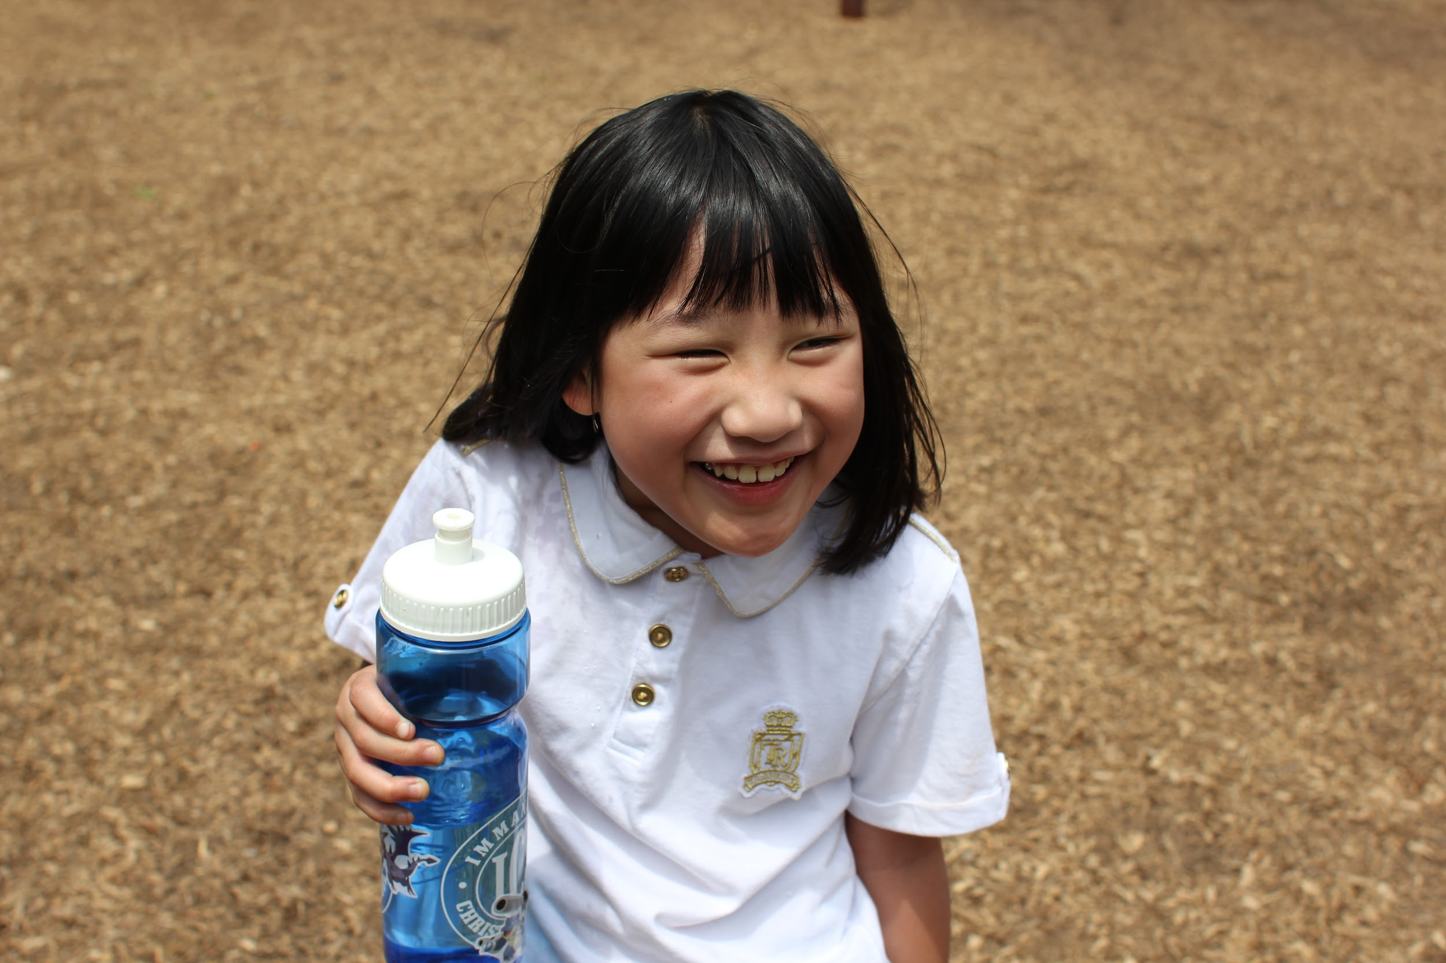
Cancellation Policies

To cancel semesterly or yearly after-school enrichment services, you may either call our center at 703-978-0008 or you may come to the center in-person. If you need to cancel services, please notify Best Academy as soon as possible. A minimum of two weeks cancellation notice is required. A partial refund will be given after recalculating the tuition for weekly enrollment. No refunds or credits will be issued for services that are not cancelled in advance, even if your child does not attend.

General Information, Policies, and Licensing Standards
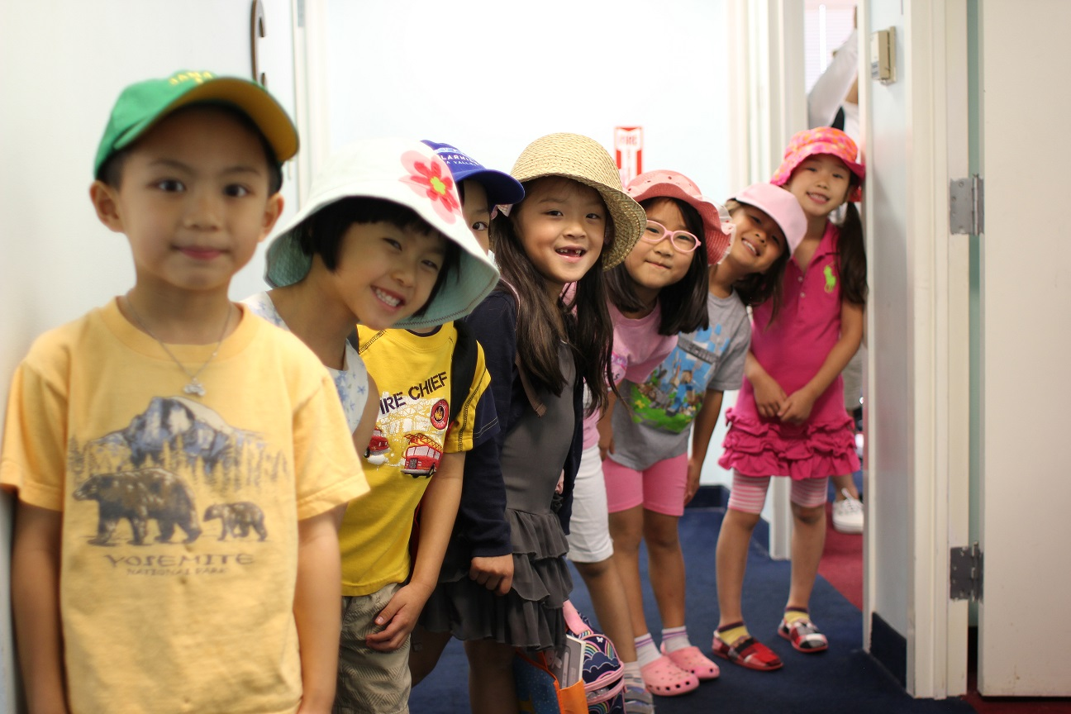
Signatures: An original signature is required on all copies of the information form.

Child Protective Services: Best Academy staff are mandated to report suspected child abuse and neglect to Child Protective Services as required by Virginia State Law.

Weather Emergencies: Best Academy follows the FCPS Office of Safety and Security policy for extreme heat and poor air quality days by eliminating strenuous outdoor activities. Best Academy provides drinks for children while outside.

Staff: Best Academy teachers have both academic backgrounds in child-related fields and experience working children in small and large group settings. Staff are basic first aid and CPR trained and attend mandatory trainings throughout the year to ensure the highest quality of programming and service.

Emergency School Closings, Delayed Openings, and Early Closings

Full Day School Closings: Best Academy follows FCPS emergency closings due to weather conditions, energy problems, or other emergencies. Please call Best Academy or check our website for updates of center openings during emergencies.

Early School Closings: The After-School Enrichment program runs from normal school closing time until 7 p.m. In the case of early school closings, please call Best Academy as soon as possible for special accommodations.

Teacher Workdays: Best Academy will be open for full-day Enrichment programs during Teacher Workdays or certain federal holidays. Please call Best Academy if you have any questions.
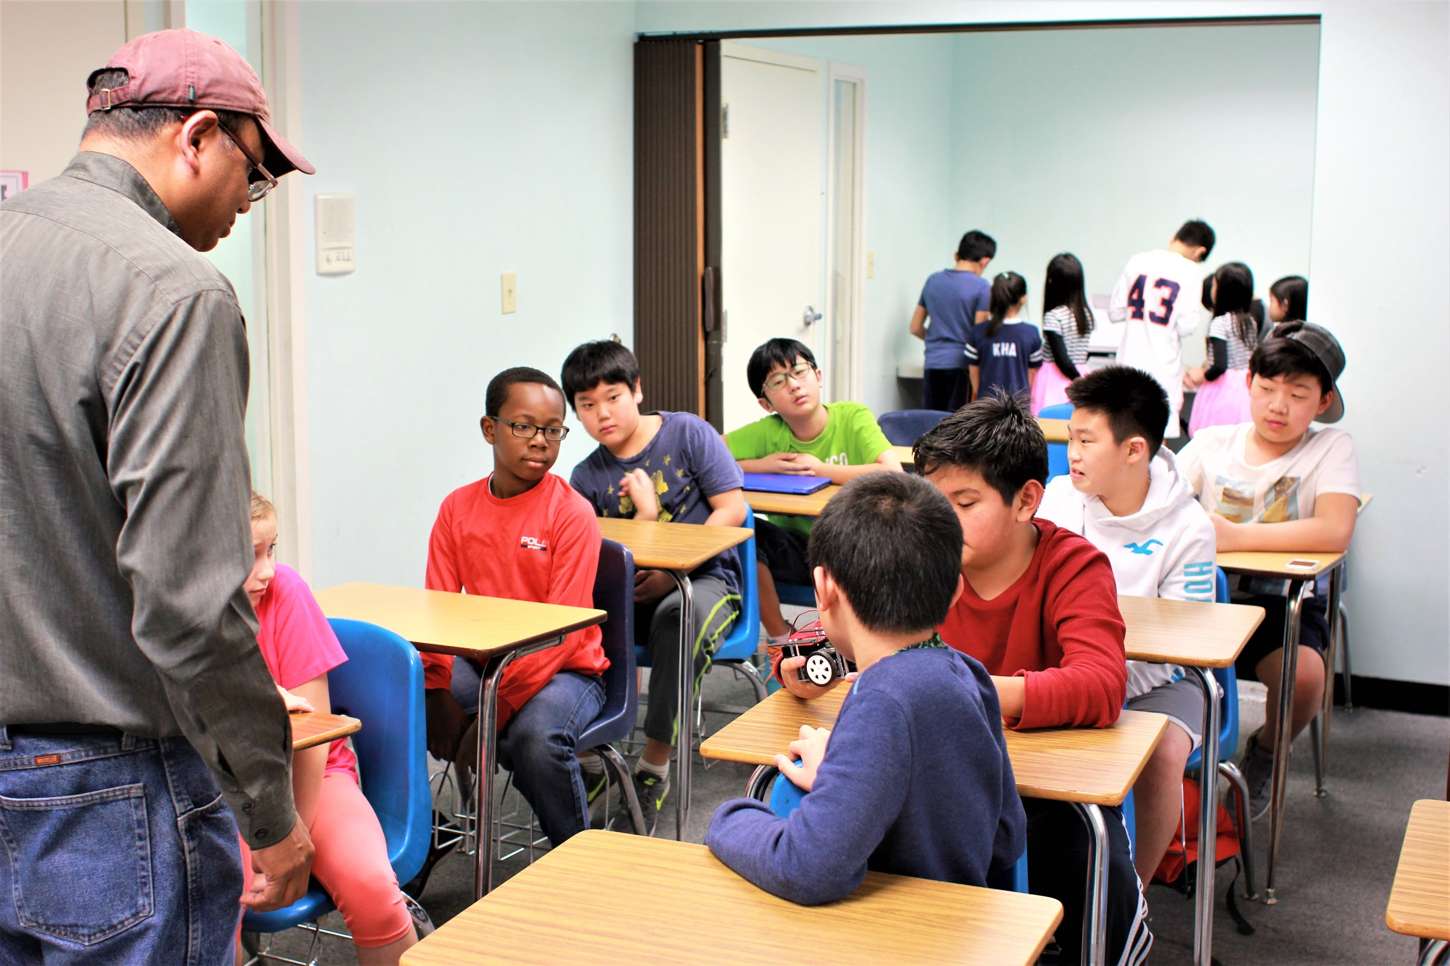
Note: Fee adjustments or refunds will not be given for Best Academy closings due to snow, weather, energy problems, emergency school closings, unanticipated calendar changes, early pick-ups or cancelled field trips.

